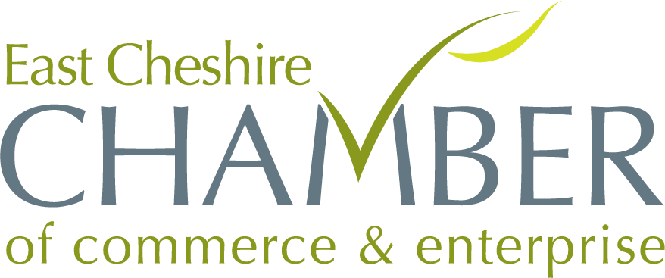

Annual Business Awards 2024
Entry Form

Small Business of the Year 2024

Open to all companies of 6 and less employees (Full Time Equivalents). Successful entrants will need to show excellent and outstanding achievement in all aspects of their organisation.
Please provide a presentation of your business and why you think your company should win this award, the judges will be looking for evidence of;
- A sound business plan and a Sales and Marketing strategy
- Strong leadership with the ability to drive the business forward
- A Commitment to Staff development & Training
- Innovation & ambition
- Strong financial performance

Company Name
Address
Type of Business
No. of Employees
Company Start Date

Please include a copy of this form with your presentation

