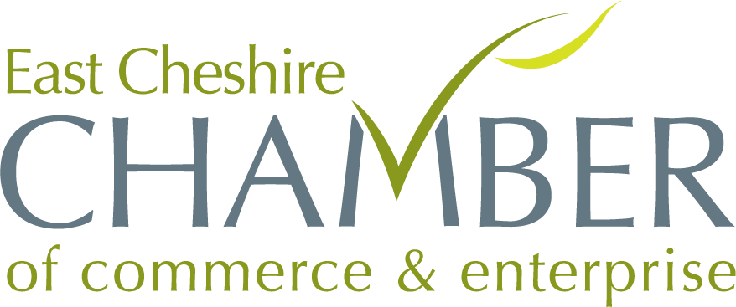

Annual Business Awards 2024
Entry Form
Professional Services Award 2024
Entrants for the Professional Services Award must be able to show the judge how they have made outstanding contributions in their respective fields or industries.
Please provide a presentation of your business and why you think your company should win this award, judges will be looking for evidence of;
- Excellence and achievement through accomplishments, innovations, or contributions
- Leadership
- Impact and Influence
- Service to the Community or Industry
- Ethical Standards
- Reputation and Recognition
Company Name
Address
Type of Business
No. of Employees
Company Start Date
- Impact on the Organisation or Industry
Please include a copy of this form with your presentation

