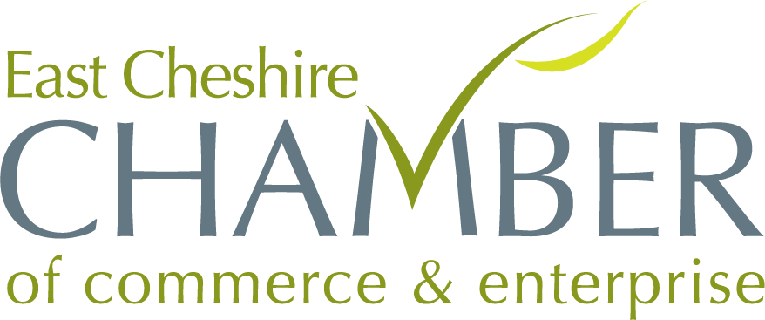

Annual Business Awards 2024

Entry Form
Excellence in Customer Service Award 2024

This Award is for the Company that demonstrates a commitment to continuously improving its standards of customer care and has a concise and well-implemented customer care policy.

Please provide a presentation of your business and why you think your company should win this award, the judges will be looking for evidence of;
- Evidence of your customer care policy
- How you deal with customer care issues and ensure quality and consistency of customer service
- Employee training & development
- How you obtain customer feedback E.g. Facebook reviews, TripAdvisor, Google and other interactive methods
- New ideas to enhance the customer experience

Company Name
Address
Type of Business
No. of Employees
Company Start Date

Please include a copy of this form with your presentation

